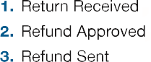

s

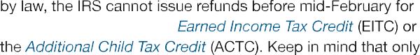

IRS Pub 2043



To check Iowa Refunds: [https:///www.idr.iowa.gov/wheresmyrefund](http://www.idr.iowa.gov/wheresmyrefund)